-- Alexa Schnetzler Project 2

--Part 1 Question 1

--Add Notes Column to mm_rental

alter table mm_rental add notes varchar(255);

--Procedure

--Procedure

CREATE OR REPLACE PROCEDURE MOVIE_RENT_SP

(p_memId in OUT NUMBER,

p_movieId in OUT Number,

p_pay in OUT Number)

AS

lv_qty NUMBER(5,2) := 1;

lv_stock NUMBER(5,2);

no_info EXCEPTION;

PRAGMA EXCEPTION_INIT(no_info, -02291);

BEGIN

--Create new order

Insert into mm_rental(rental_id,member_id, movie_ID, PAYMENT_METHODS_ID)

VALUES (MM_RENTAL_SEQ.NEXTVAL,p_memid, p_movieId, p_pay);

--Update Stock

Update mm_movie

set MOVIE_QTY = movie_QTY - lv_qty

WHERE p_movieId = movie_ID

AND movie_qty > 0;

--Put stock into variable to output

select MOVIE_QTY

into lv_stock

from mm_movie

WHERE p_movieId = movie_ID

AND movie_qty > 0;

--Output everything

DBMS_OUTPUT.PUT_LINE('New Order Report Created On: ' || sysdate);

DBMS_OUTPUT.PUT_LINE('****************************************************');

DBMS_OUTPUT.PUT_LINE('Rental Id: ' || MM_RENTAL_SEQ.NEXTVAL);

DBMS_OUTPUT.PUT_LINE('Member Id: ' || p_memId);

DBMS_OUTPUT.PUT_LINE('Movie Id: ' || p_movieId);

DBMS_OUTPUT.PUT_LINE('Payment Type: ' || p_pay);

DBMS_OUTPUT.PUT_LINE('Movie Stock: ' || lv_stock);

--Exceptions

exception

when no_info then

DBMS_OUTPUT.PUT_LINE('One of your values does not exist in our database. Please review your values and try again.');

when NO_DATA_FOUND then

--Update Stock

Insert into mm_rental(rental_id,member_id, movie_ID, CHECKOUT_DATE, PAYMENT_METHODS_ID, notes)

VALUES (MM_RENTAL_SEQ.NEXTVAL,p_memid, p_movieId, NULL, NULL, 'Order not completed. Movie not in stock. Contact customer.');

DBMS_OUTPUT.PUT_LINE('Sorry, that movie is currently not in stock.');

END MOVIE_RENT_SP;

--Anon Block SUCCESSFUL

Declare

lv_memId NUMBER(5,3) := 13;

lv_movieId NUMBER(5,3) := 12;

lv_pay Number(2,0) := 4;

BEGIN

movie_rent_sp(lv_memId, lv_movieId, lv_pay);

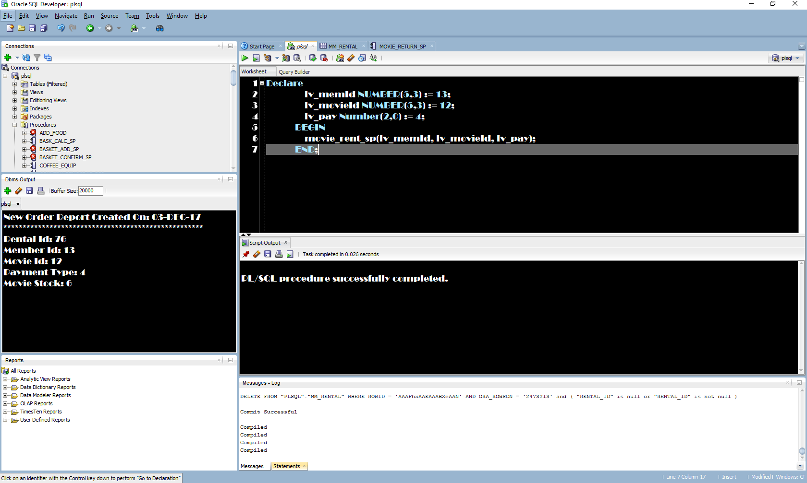 END;

--Anon Block Error

Declare

lv_memId NUMBER(5,3) := 62;

lv_movieId NUMBER(5,3) := 12;

lv_pay Number(2,0) := 4;

BEGIN

movie_rent_sp(lv_memId, lv_movieId, lv_pay);

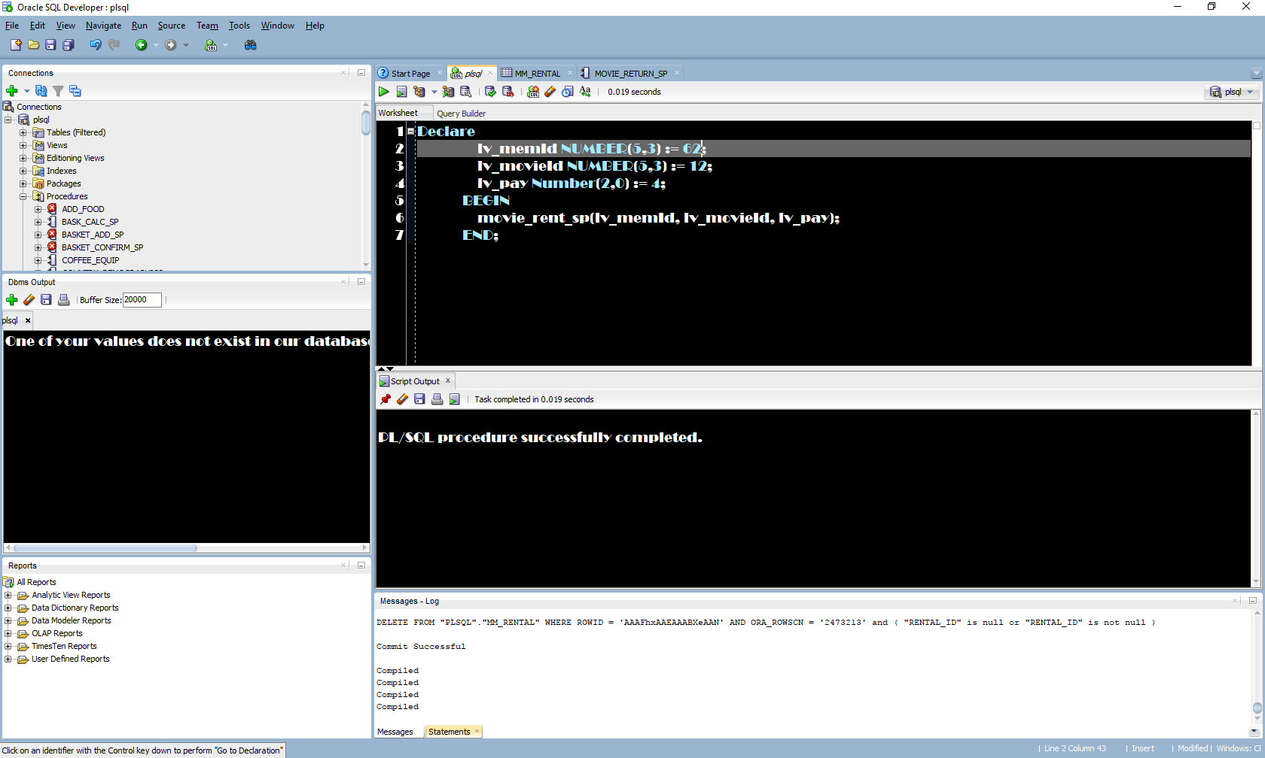 END;

--Part 1 Question 2

--PROCEDURE

CREATE OR REPLACE PROCEDURE MOVIE_RETURN_SP

(p_memId IN NUMBER,

p_movieId IN NUMBER)

AS

lv_rental NUMBER(5,2);

lv_qty NUMBER(5,2) := 1;

no_info EXCEPTION;

PRAGMA EXCEPTION_INIT(no_info, -02291);

BEGIN

--Get the rental id

select rental_id

into lv_rental

from mm_rental

where p_memid = member_id

AND p_movieId = movie_id;

--Check the movie back in

UPDATE mm_rental

set checkin_date = sysdate

where p_memid = member_id

AND p_movieId = movie_id

AND checkin_date IS NULL;

--Update movie stock

Update mm_movie

set MOVIE_QTY = movie_QTY + lv_qty

WHERE p_movieId = movie_ID;

DBMS_OUTPUT.PUT_LINE('Movie rental id ' || lv_rental || ' was checked in on ' || sysdate);

--Exceptions

exception

when no_info then

DBMS_OUTPUT.PUT_LINE('One of your values does not exist in our database. Please review your values and try again.');

when NO_DATA_FOUND then

DBMS_OUTPUT.PUT_LINE('Sorry no data was found based on the given data.');

END MOVIE_RETURN_SP;

--Anon Block Successful

Declare

lv_memId NUMBER(5,3) := 13;

lv_movieId NUMBER(5,3) := 12;

BEGIN

movie_return_sp(lv_memId, lv_movieId);

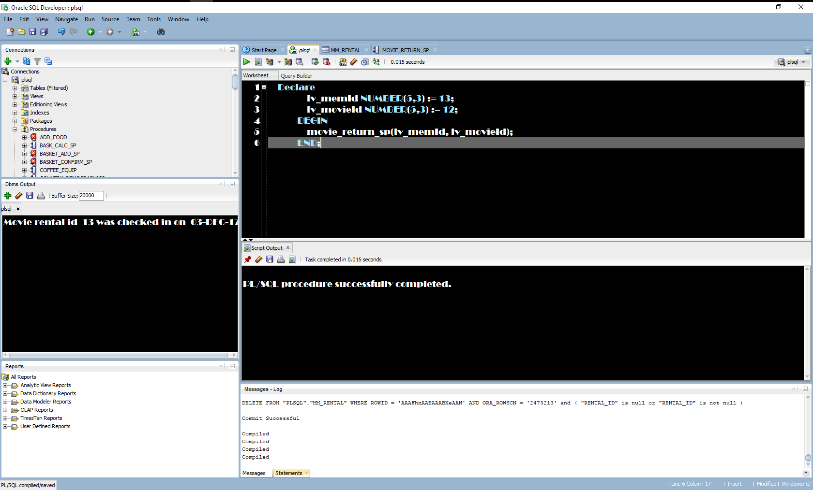 END;

--Anon Block Error

Declare

lv_memId NUMBER(5,3) := 69;

lv_movieId NUMBER(5,3) := 12;

BEGIN

movie_return_sp(lv_memId, lv_movieId);

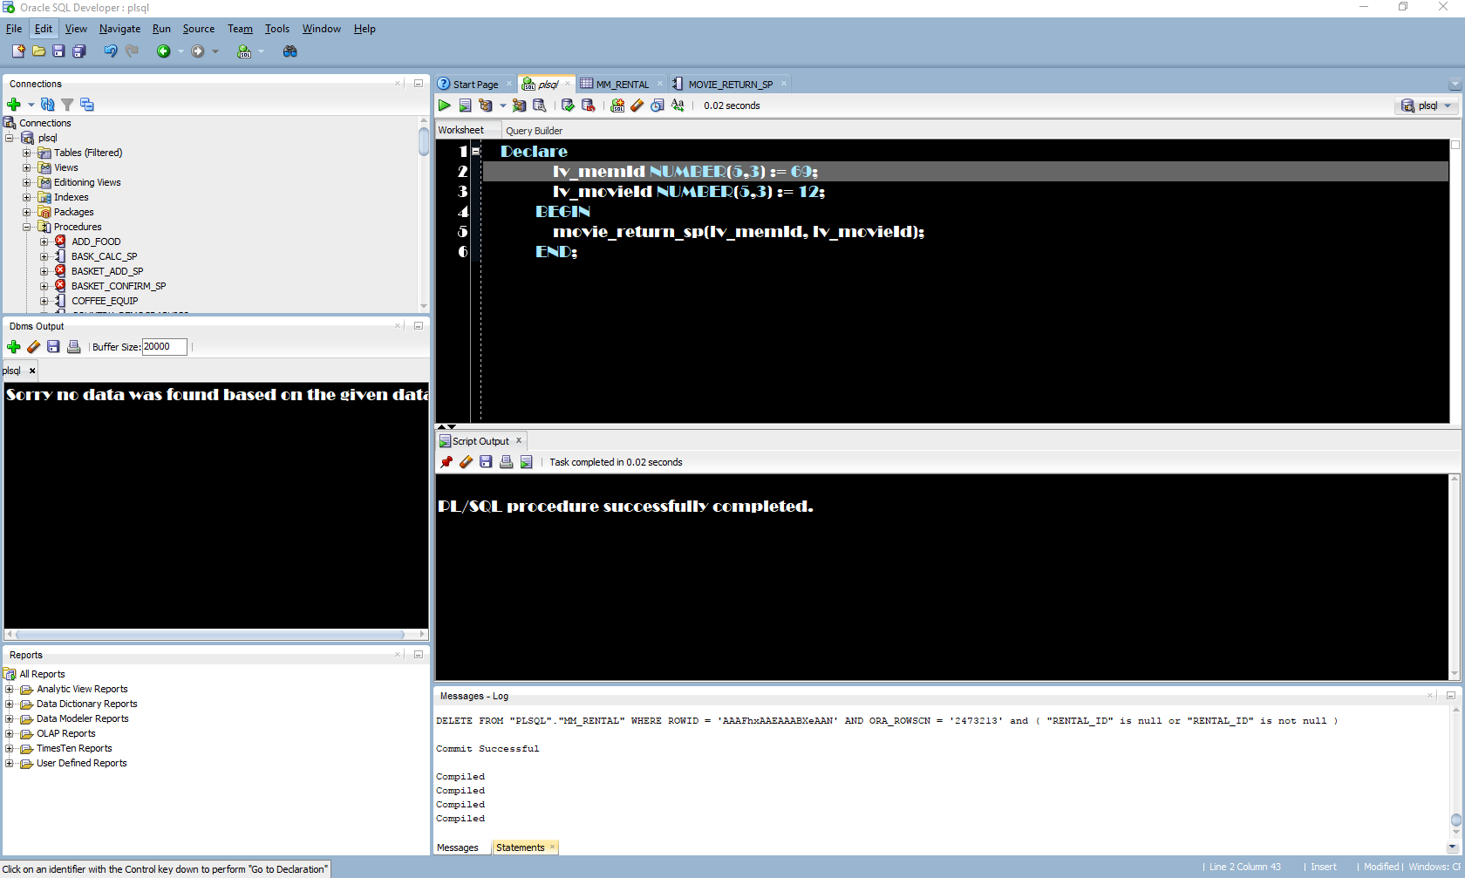 END;

--FUNCTION

create or replace FUNCTION MOVIE_STOCK_SF

(p_movieId IN NUMBER)

RETURN VARCHAR2

AS

lv_stock NUMBER(5,2);

lv_title VARCHAR(255);

BEGIN

select MOVIE_QTY, movie_title

into lv_stock, lv_title

from mm_movie

WHERE p_movieId = movie_ID;

if lv_stock > 0 THEN

Return lv_title || ' is available. There are ' || lv_stock || ' left in stock.';

elsif lv_stock = 0 THEN

Return lv_title || ' is not in stock. Please check again later.';

Else

Return 'An error occurred finding the stcck. Please try again or contact customer service.';

END IF;

exception

when no_data_found then

RETURN 'That id does not match a movie in our database. Please review the id and try again.';

END MOVIE_STOCK_SF;

--Anon Block SUCCESSFUL

Declare

lv_stock VARCHAR2(255);

lv_movieId NUMBER(5,3) := 12;

BEGIN

lv_stock := movie_stock_sf (lv_movieId);

DBMS_OUTPUT.PUT_LINE(lv_stock);

END;

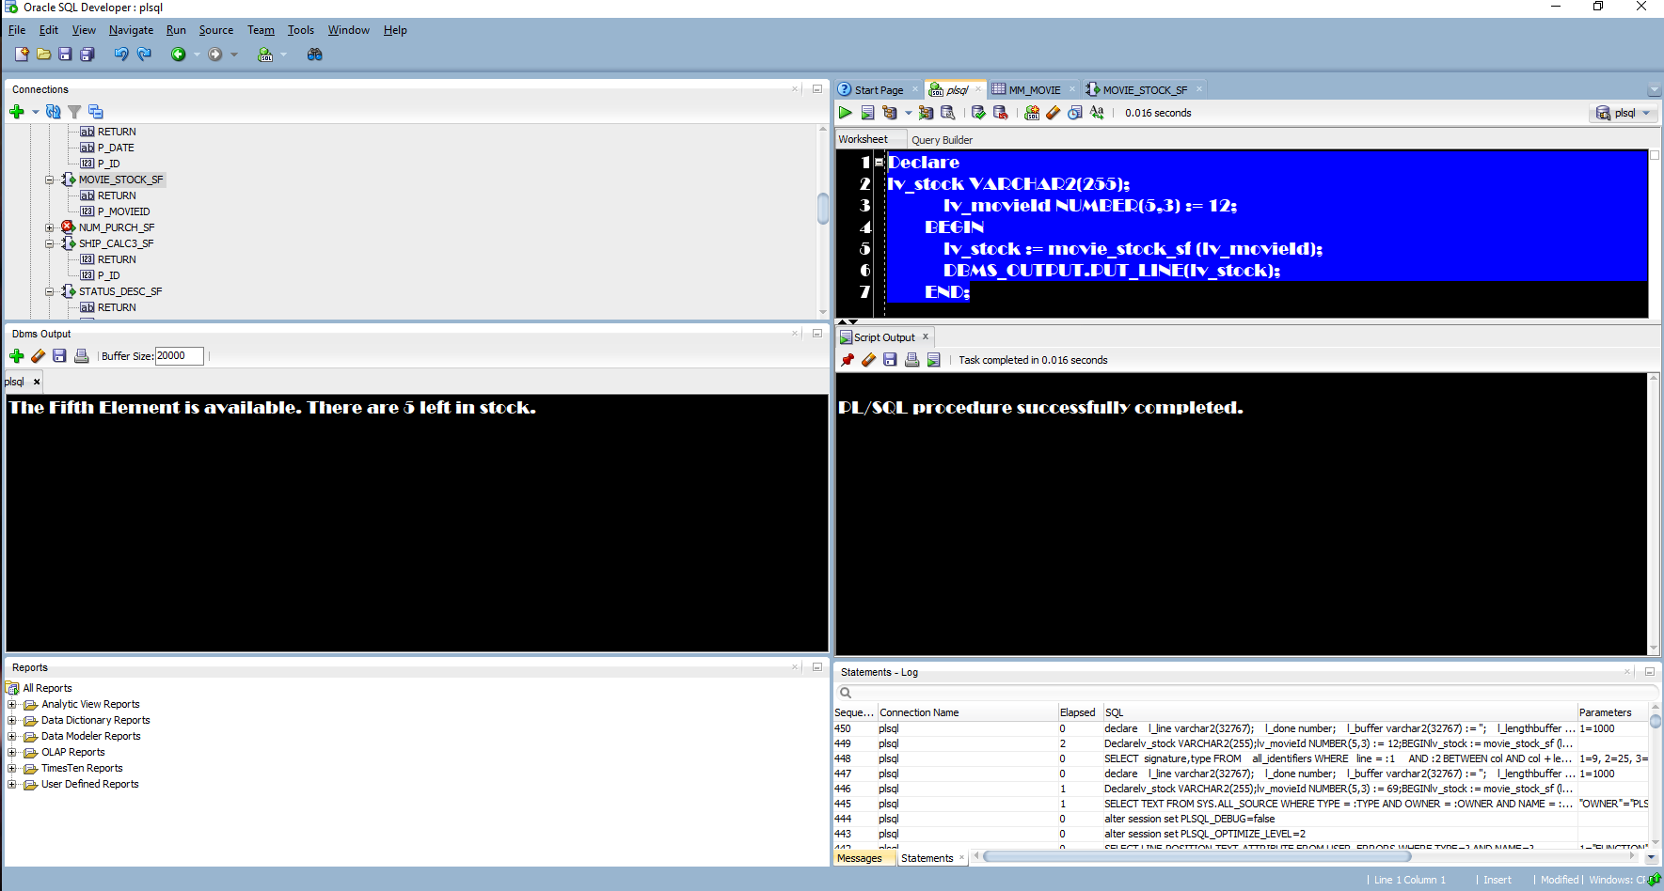

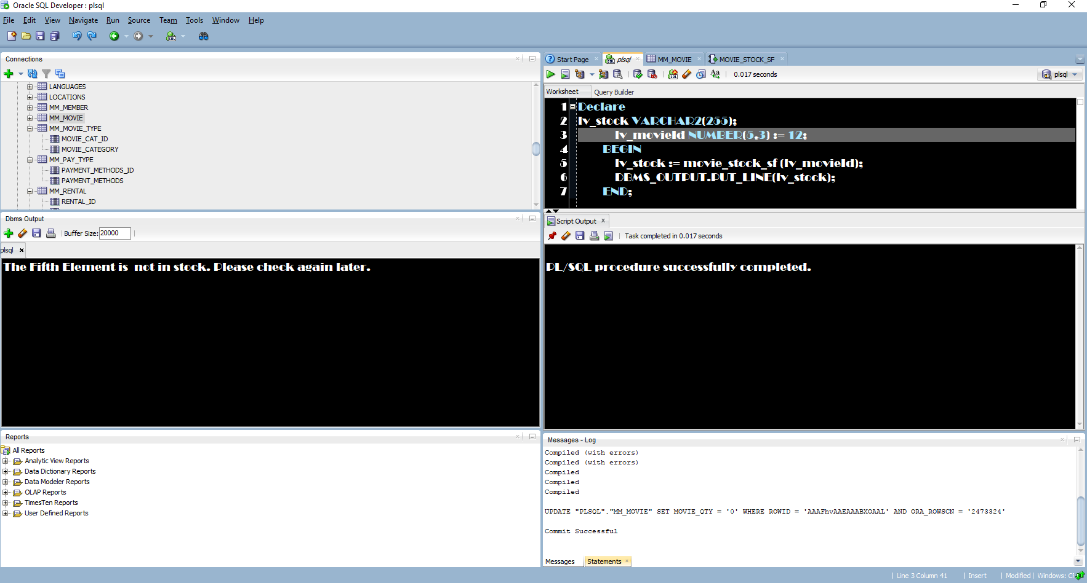Out of stock

--Anon Block Error

Declare

lv_stock VARCHAR2(255);

lv_movieId NUMBER(5,3) := 69;

BEGIN

lv_stock := movie_stock_sf (lv_movieId);

DBMS_OUTPUT.PUT_LINE(lv_stock);

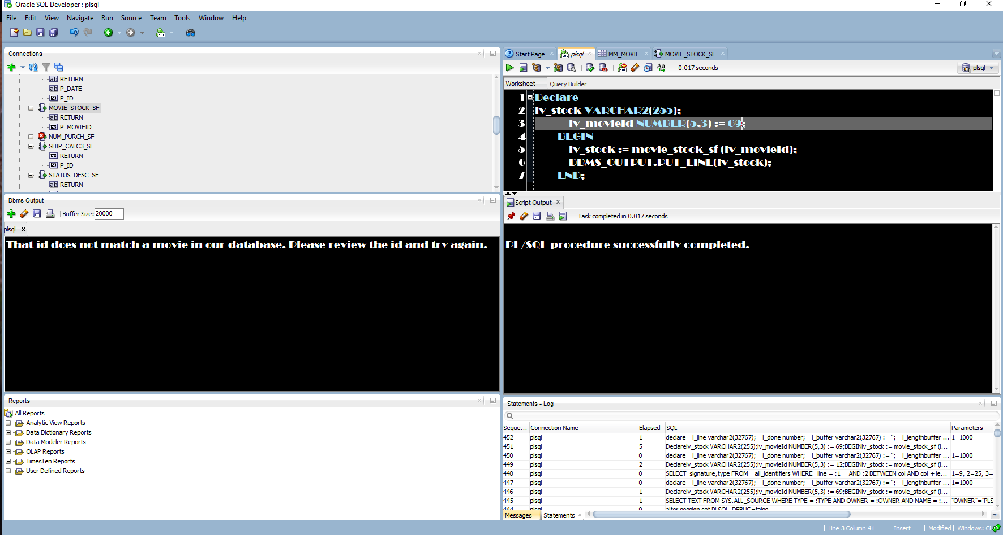 END;

--Part 2 Question 2

--package create

create or replace PACKAGE MOVIE_RENTALS_PKG AS

FUNCTION MOVIE_STOCK_SF

(p_movieId IN NUMBER)

RETURN VARCHAR2;

PROCEDURE MOVIE_RENT_SP

(p_memId in OUT NUMBER,

p_movieId in OUT Number,

p_pay in OUT Number);

PROCEDURE MOVIE_RETURN_SP

(p_memId IN NUMBER,

p_movieId IN NUMBER);

END MOVIE_RENTALS_PKG;

--Package BODY

CREATE OR REPLACE

PACKAGE BODY MOVIE_RENTALS_PKG AS

FUNCTION MOVIE_STOCK_SF

(p_movieId IN NUMBER)

RETURN VARCHAR2

AS

lv_stock NUMBER(5,2);

lv_title VARCHAR(255);

BEGIN

select MOVIE_QTY, movie_title

into lv_stock, lv_title

from mm_movie

WHERE p_movieId = movie_ID;

if lv_stock > 0 THEN

Return lv_title || ' is available. There are ' || lv_stock || ' left in stock.';

elsif lv_stock = 0 THEN

Return lv_title || ' is not in stock. Please check again later.';

Else

Return 'An error occurred finding the stcck. Please try again or contact customer service.';

END IF;

exception

when no_data_found then

RETURN 'That id does not match a movie in our database. Please review the id and try again.';

END MOVIE_STOCK_SF;

PROCEDURE MOVIE_RENT_SP

(p_memId in OUT NUMBER,

p_movieId in OUT Number,

p_pay in OUT Number)

AS

lv_qty NUMBER(5,2) := 1;

lv_stock NUMBER(5,2);

no_info EXCEPTION;

PRAGMA EXCEPTION_INIT(no_info, -02291);

BEGIN

--Create new order

Insert into mm_rental(rental_id,member_id, movie_ID, PAYMENT_METHODS_ID)

VALUES (MM_RENTAL_SEQ.NEXTVAL,p_memid, p_movieId, p_pay);

--Update Stock

Update mm_movie

set MOVIE_QTY = movie_QTY - lv_qty

WHERE p_movieId = movie_ID

AND movie_qty > 0;

--Put stock into variable to output

select MOVIE_QTY

into lv_stock

from mm_movie

WHERE p_movieId = movie_ID

AND movie_qty > 0;

--Output everything

DBMS_OUTPUT.PUT_LINE('New Order Report Created On: ' || sysdate);

DBMS_OUTPUT.PUT_LINE('****************************************************');

DBMS_OUTPUT.PUT_LINE('Rental Id: ' || MM_RENTAL_SEQ.NEXTVAL);

DBMS_OUTPUT.PUT_LINE('Member Id: ' || p_memId);

DBMS_OUTPUT.PUT_LINE('Movie Id: ' || p_movieId);

DBMS_OUTPUT.PUT_LINE('Payment Type: ' || p_pay);

DBMS_OUTPUT.PUT_LINE('Movie Stock: ' || lv_stock);

--Exceptions

exception

when no_info then

DBMS_OUTPUT.PUT_LINE('One of your values does not exist in our database. Please review your values and try again.');

when NO_DATA_FOUND then

--Update Stock

Insert into mm_rental(rental_id,member_id, movie_ID, CHECKOUT_DATE, PAYMENT_METHODS_ID, notes)

VALUES (MM_RENTAL_SEQ.NEXTVAL,p_memid, p_movieId, NULL, NULL, 'Order not completed. Movie not in stock. Contact customer.');

DBMS_OUTPUT.PUT_LINE('Sorry, that movie is currently not in stock.');

END MOVIE_RENT_SP;

PROCEDURE MOVIE_RETURN_SP

(p_memId IN NUMBER,

p_movieId IN NUMBER)

AS

lv_rental NUMBER(5,2);

lv_qty NUMBER(5,2) := 1;

no_info EXCEPTION;

PRAGMA EXCEPTION_INIT(no_info, -02291);

BEGIN

--Get the rental id

select rental_id

into lv_rental

from mm_rental

where p_memid = member_id

AND p_movieId = movie_id;

--Check the movie back in

UPDATE mm_rental

set checkin_date = sysdate

where p_memid = member_id

AND p_movieId = movie_id

AND checkin_date IS NULL;

--Update movie stock

Update mm_movie

set MOVIE_QTY = movie_QTY + lv_qty

WHERE p_movieId = movie_ID;

DBMS_OUTPUT.PUT_LINE('Movie rental id ' || lv_rental || ' was checked in on ' || sysdate);

--Exceptions

exception

when no_info then

DBMS_OUTPUT.PUT_LINE('One of your values does not exist in our database. Please review your values and try again.');

when NO_DATA_FOUND then

DBMS_OUTPUT.PUT_LINE('Sorry no data was found based on the given data.');

END MOVIE_RETURN_SP;

END MOVIE_RENTALS_PKG;

--Anon Block id:6

Declare

lv_stock Varchar2(255);

BEGIN

lv_stock := MOVIE_RENTALS_PKG.movie_stock_sf(6);

DBMS_OUTPUT.PUT_LINE(lv_stock);

END;

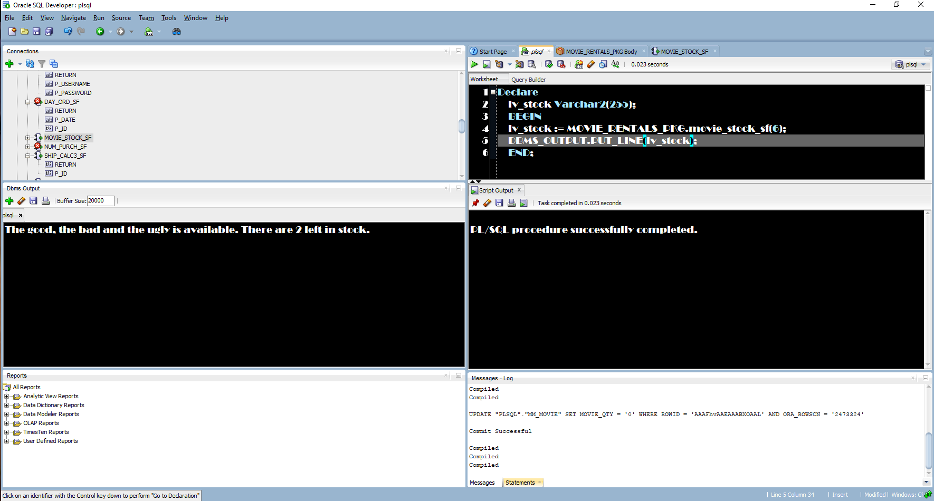

--Anon block id:7

Declare

lv_stock Varchar2(255);

BEGIN

lv_stock := MOVIE_RENTALS_PKG.movie_stock_sf(7);

DBMS_OUTPUT.PUT_LINE(lv_stock);

END;

--Part 3 Question 1

--PACKAGE create

create or replace PACKAGE MOVIE_RENTALS_PKG AS

FUNCTION MOVIE_STOCK_SF

(p_movieId IN NUMBER)

RETURN VARCHAR2;

FUNCTION MOVIE_STOCK_SF

(p_movieId IN VARCHAR2)

RETURN VARCHAR2;

PROCEDURE MOVIE_RENT_SP

(p_memId in OUT NUMBER,

p_movieId in OUT Number,

p_pay in OUT Number);

PROCEDURE MOVIE_RETURN_SP

(p_memId IN NUMBER,

p_movieId IN NUMBER);

END MOVIE_RENTALS_PKG;

--Package BODY

create or replace PACKAGE BODY MOVIE_RENTALS_PKG AS

FUNCTION MOVIE_STOCK_SF

(p_movieId IN NUMBER)

RETURN VARCHAR2

AS

lv_stock NUMBER(5,2);

lv_title VARCHAR(255);

BEGIN

select MOVIE_QTY, movie_title

into lv_stock, lv_title

from mm_movie

WHERE p_movieId = movie_ID;

if lv_stock > 0 THEN

Return lv_title || ' is available. There are ' || lv_stock || ' left in stock.';

elsif lv_stock = 0 THEN

Return lv_title || ' is not in stock. Please check again later.';

Else

Return 'An error occurred finding the stcck. Please try again or contact customer service.';

END IF;

exception

when no_data_found then

RETURN 'That id does not match a movie in our database. Please review the id and try again.';

END MOVIE_STOCK_SF;

FUNCTION MOVIE_STOCK_SF

(p_movieId IN VARCHAR2)

RETURN VARCHAR2

AS

lv_stock NUMBER(5,2);

lv_title VARCHAR(255);

BEGIN

select MOVIE_QTY, movie_title

into lv_stock, lv_title

from mm_movie

WHERE p_movieId = movie_title;

if lv_stock > 0 THEN

Return lv_title || ' is available. There are ' || lv_stock || ' left in stock.';

elsif lv_stock = 0 THEN

Return lv_title || ' is not in stock. Please check again later.';

Else

Return 'An error occurred finding the stcck. Please try again or contact customer service.';

END IF;

exception

when no_data_found then

RETURN 'That title does not match a movie in our database. Please review the id and try again.';

END MOVIE_STOCK_SF;

PROCEDURE MOVIE_RENT_SP

(p_memId in OUT NUMBER,

p_movieId in OUT Number,

p_pay in OUT Number)

AS

lv_qty NUMBER(5,2) := 1;

lv_stock NUMBER(5,2);

no_info EXCEPTION;

PRAGMA EXCEPTION_INIT(no_info, -02291);

BEGIN

--Create new order

Insert into mm_rental(rental_id,member_id, movie_ID, PAYMENT_METHODS_ID)

VALUES (MM_RENTAL_SEQ.NEXTVAL,p_memid, p_movieId, p_pay);

--Update Stock

Update mm_movie

set MOVIE_QTY = movie_QTY - lv_qty

WHERE p_movieId = movie_ID

AND movie_qty > 0;

--Put stock into variable to output

select MOVIE_QTY

into lv_stock

from mm_movie

WHERE p_movieId = movie_ID

AND movie_qty > 0;

--Output everything

DBMS_OUTPUT.PUT_LINE('New Order Report Created On: ' || sysdate);

DBMS_OUTPUT.PUT_LINE('****************************************************');

DBMS_OUTPUT.PUT_LINE('Rental Id: ' || MM_RENTAL_SEQ.NEXTVAL);

DBMS_OUTPUT.PUT_LINE('Member Id: ' || p_memId);

DBMS_OUTPUT.PUT_LINE('Movie Id: ' || p_movieId);

DBMS_OUTPUT.PUT_LINE('Payment Type: ' || p_pay);

DBMS_OUTPUT.PUT_LINE('Movie Stock: ' || lv_stock);

--Exceptions

exception

when no_info then

DBMS_OUTPUT.PUT_LINE('One of your values does not exist in our database. Please review your values and try again.');

when NO_DATA_FOUND then

--Update Stock

Insert into mm_rental(rental_id,member_id, movie_ID, CHECKOUT_DATE, PAYMENT_METHODS_ID, notes)

VALUES (MM_RENTAL_SEQ.NEXTVAL,p_memid, p_movieId, NULL, NULL, 'Order not completed. Movie not in stock. Contact customer.');

DBMS_OUTPUT.PUT_LINE('Sorry, that movie is currently not in stock.');

END MOVIE_RENT_SP;

PROCEDURE MOVIE_RETURN_SP

(p_memId IN NUMBER,

p_movieId IN NUMBER)

AS

lv_rental NUMBER(5,2);

lv_qty NUMBER(5,2) := 1;

no_info EXCEPTION;

PRAGMA EXCEPTION_INIT(no_info, -02291);

BEGIN

--Get the rental id

select rental_id

into lv_rental

from mm_rental

where p_memid = member_id

AND p_movieId = movie_id;

--Check the movie back in

UPDATE mm_rental

set checkin_date = sysdate

where p_memid = member_id

AND p_movieId = movie_id

AND checkin_date IS NULL;

--Update movie stock

Update mm_movie

set MOVIE_QTY = movie_QTY + lv_qty

WHERE p_movieId = movie_ID;

DBMS_OUTPUT.PUT_LINE('Movie rental id ' || lv_rental || ' was checked in on ' || sysdate);

--Exceptions

exception

when no_info then

DBMS_OUTPUT.PUT_LINE('One of your values does not exist in our database. Please review your values and try again.');

when NO_DATA_FOUND then

DBMS_OUTPUT.PUT_LINE('Sorry no data was found based on the given data.');

END MOVIE_RETURN_SP;

END MOVIE_RENTALS_PKG;

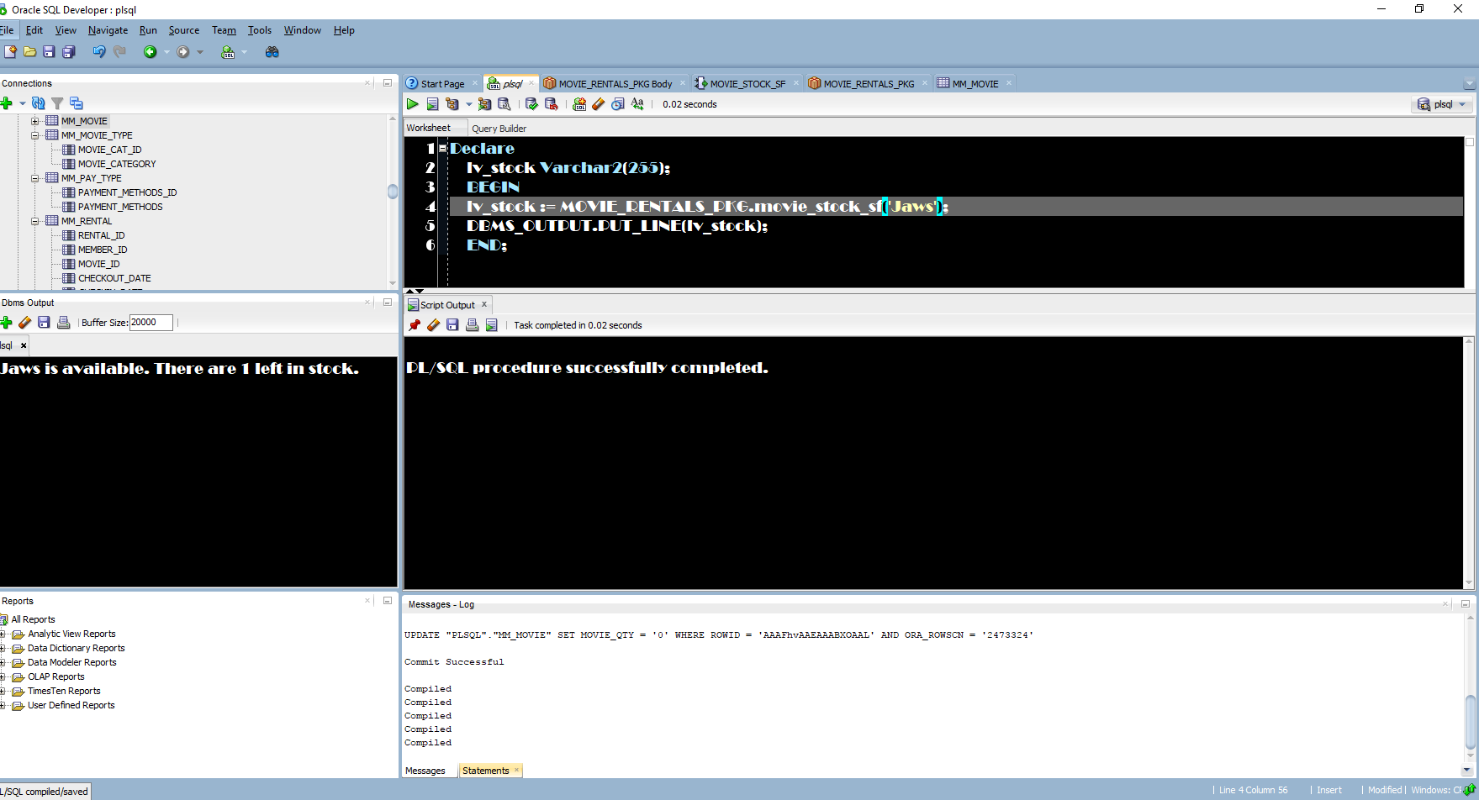 --anon block successful

Declare

lv_stock Varchar2(255);

BEGIN

lv_stock := MOVIE_RENTALS_PKG.movie_stock_sf('Jaws');

DBMS_OUTPUT.PUT_LINE(lv_stock);

END;

--anon block error

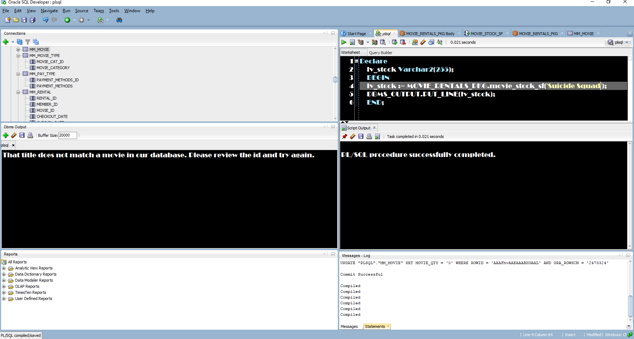

Declare

lv_stock Varchar2(255);

BEGIN

lv_stock := MOVIE_RENTALS_PKG.movie_stock_sf('Saw');

DBMS_OUTPUT.PUT_LINE(lv_stock);

END;

--Part 3 Question 2

--Function

CREATE OR REPLACE FUNCTION MOVIE_SUGGESTION_SF

(p_category IN VARCHAR2)

RETURN VARCHAR2

AS

no_value exception;

PRAGMA EXCEPTION_INIT(no_value, -06503);

CURSOR category IS

SELECT movie_category, movie_title

FROM MM_MOVIE NATURAL JOIN MM_MOVIE_TYPE

WHERE UPPER(p_category) = UPPER(movie_category);

lv_name category%ROWTYPE;

BEGIN

open category;

LOOP

fetch category into lv_name;

IF category%Rowcount >= 1 THEN

dbms_output.put_line(lv_name.movie_title);

ELSE DBMS_OUTPUT.PUT_LINE('Sorry, our system could not find a movie title within that category.');

END IF;

exit when category%NOTFOUND;

END LOOP;

close category;

exception

when no_value then

DBMS_OUTPUT.PUT_LINE('Sorry, our system could not find a movie title within that category.');

when no_data_found then

DBMS_OUTPUT.PUT_LINE('Sorry, our system could not find a movie title within that category.');

END MOVIE_SUGGESTION_SF;

--Anon Block

DECLARE

lv_category VARCHAR2(255) :='&Category';

lv_titles Varchar2(255);

BEGIN

DBMS_OUTPUT.Put_Line('Movies Titles from that cateogry:');

DBMS_OUTPUT.Put_Line('******************************************');

lv_titles := MOVIE_SUGGESTION_SF(lv_category);

END;

